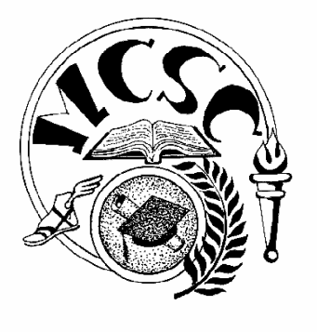
Merrillville Community School Corporation
BOARD OF SCHOOL TRUSTEES
Regular Board Meeting Agenda

Tuesday, March 6, 2018 Administrative Service Center
7:30PM 6701 Delaware Street, Merrillville

PRE-MEETING EXECUTIVE SESSION – 6:30 PM
IC 5-14-1.5-6.1,(b),(9)

- Call To Order
Opening Moment of Reflection
Pledge of Allegiance
- Approval of Minutes for the February 20, 2018 Pre and Regular Board Meetings and the February 27, 2018 Special Board Meeting – Board
- Presentation of Claims for Approval – Ms. Damianick
- Recognition of Miller School for Living Wax Museum in honor of Black History Month – Mr. Berta, Ms. Griffin
- Recognition of Merrillville High School Thespian Troupe – Mr. Berta, Mr. Mackey
- Recognition of Merrillville High School Advanced Orchestra – Mr. Berta, Ms. Rosenthal
- Recommendation to Approve the Updated Agreement between the Merrillville Community School Corporation and the Merrillville Community School Bus Drivers’ Association – Mr. Berta, Mr. Dickson
- Recommendation to Approve the Updated Agreement between the Merrillville Community School Corporation and the Merrillville Community School Local 73, Service employees International Union, AFL-CIO – Mr. Berta, Mr. Dickson
- Presentation of Updated Board Policy 3.42 Sexual Harassment Prevention Policy [First Presentation] – Mr. Berta
- Recommendation to Purchase Services for Installation of Boilers at Merrillville Intermediate School – Ms. Damianick
- Recommendation to Approve Fund Raiser Requests – Mr. Berta
- Recommendation to Accept Donations – Mr. Berta
- Personnel Report and Recommendations – Mr. Doane
- Additional Business and Community Concerns – Administration, Community, Board

