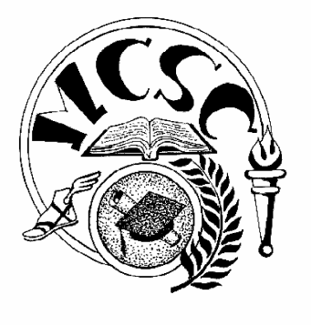
Merrillville Community School Corporation
BOARD OF SCHOOL TRUSTEES
Special Board Meeting Agenda

Thursday, March 8, 2018 Administrative Service Center
5:30PM 6701 Delaware Street, Merrillville

Executive Session

IC 5-14-1.5-6.1,(b),(5)

